import gdsfactory as gf

def make_waveguide(length=10):
c = gf.components.straight(length=length)
return c

waveguide = make_waveguide(length=25)
waveguide.show()

def make_bent_waveguide(length1=10,length2=20):
c = gf.Component()
wg1 = c.add_ref(gf.components.straight(length=length1))
bend = c.add_ref(gf.components.bend_euler())
wg2 = c.add_ref(gf.components.straight(length=length2))
bend.connect("o1",wg1.ports["o2"])
wg2.connect("o1", bend.ports["o2"])
c.add_port("o1", port=wg1.ports["o1"])
c.add_port("o2", port=wg2.ports["o2"])
return c

1 | Python/GDSFactory environment
2 | Generic PDK activation
3 | gf.Component()
4 | Standard GDSFactory components
5 | add_ref()
6 | Component vs reference
7 | Optical ports
8 | .connect()
9 | .move()
10 | Automatic routing
11 | Cross-sections
12 | Bend-radius constraints
13 | Parent-level ports
14 | Parameterized Python functions
15 | @gf.cell
16 | Cell caching
17 | Hierarchical layout
18 | Top-level components
19 | Bounding boxes
20 | GDS export
21 | KLayout inspection

import gdsfactory as gf
from gdsfactory.gpdk import get_generic_pdk

get_generic_pdk().activate()
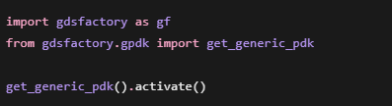

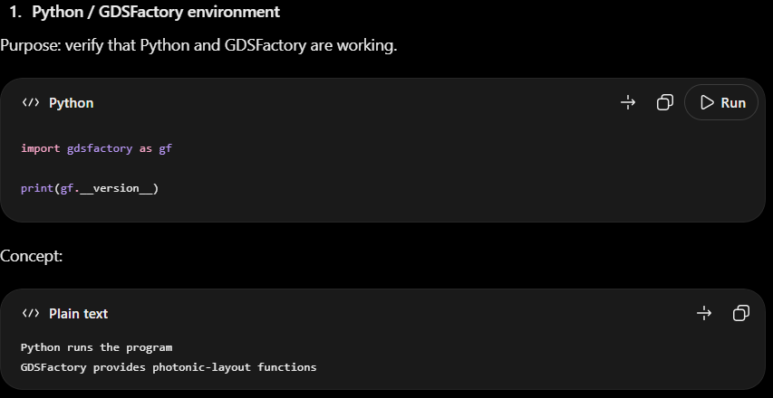

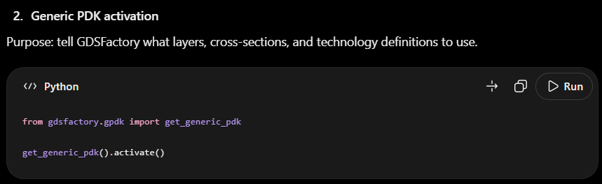
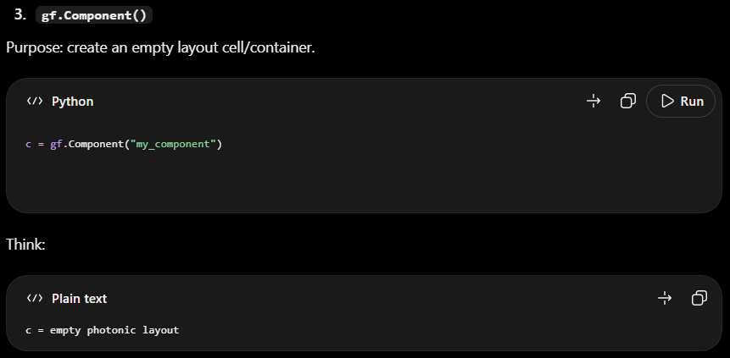

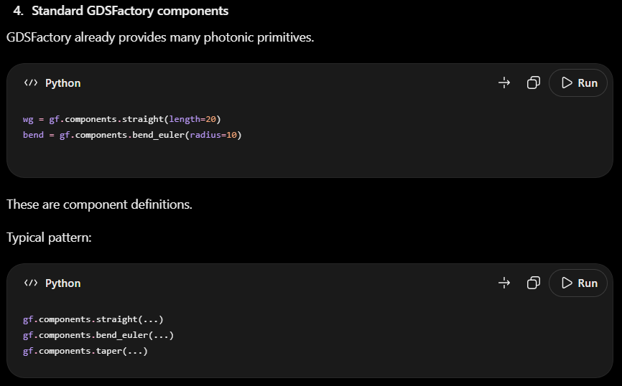

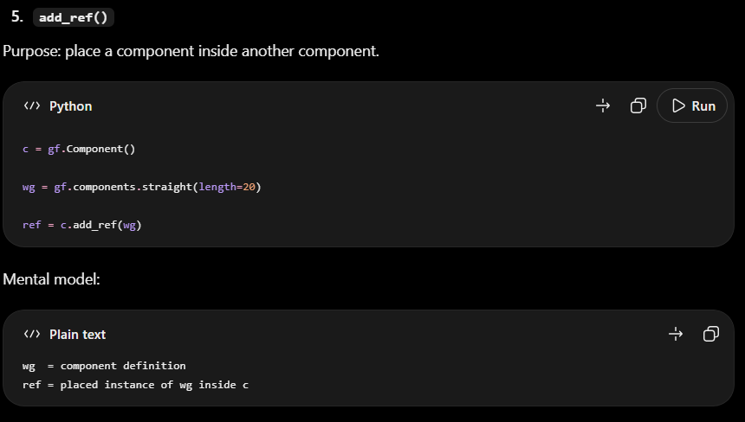

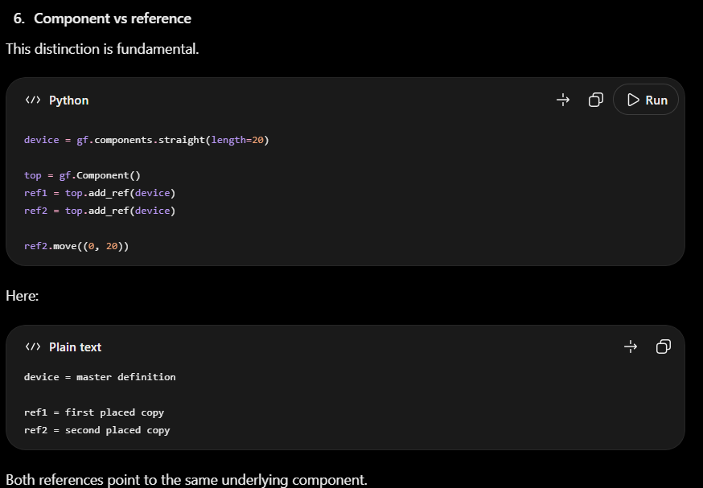
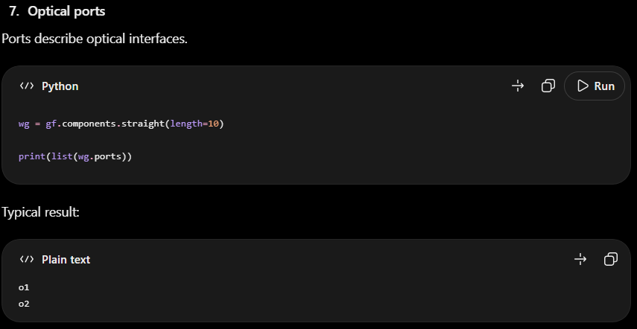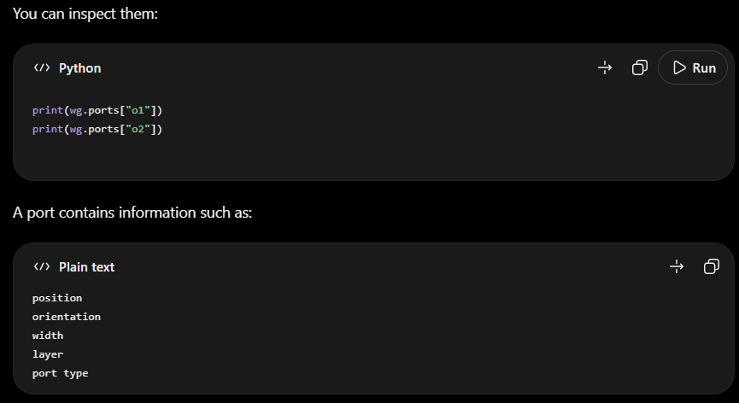

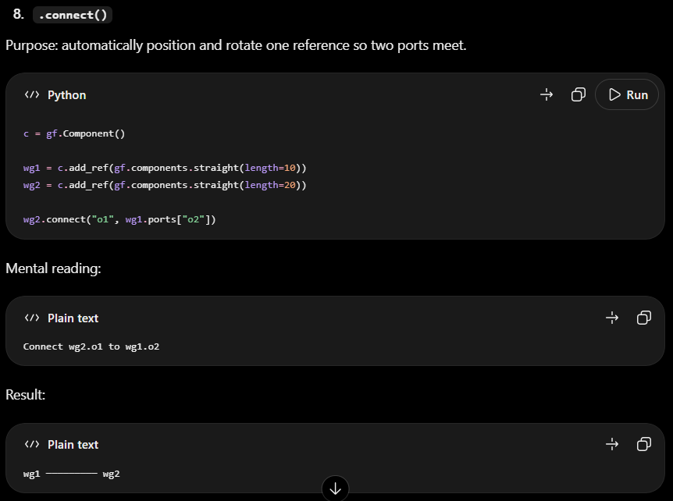

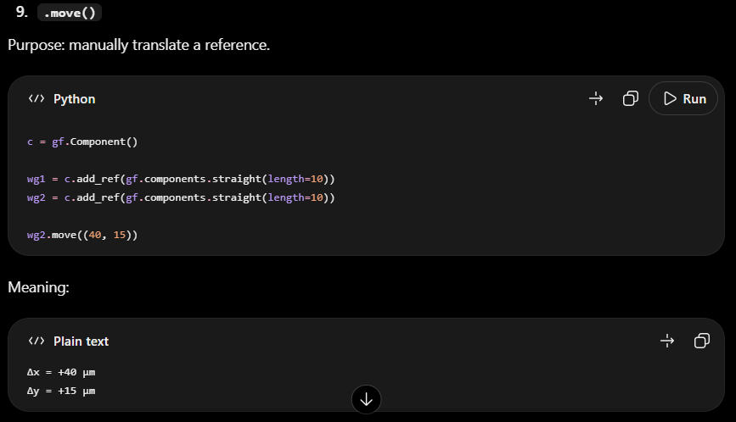
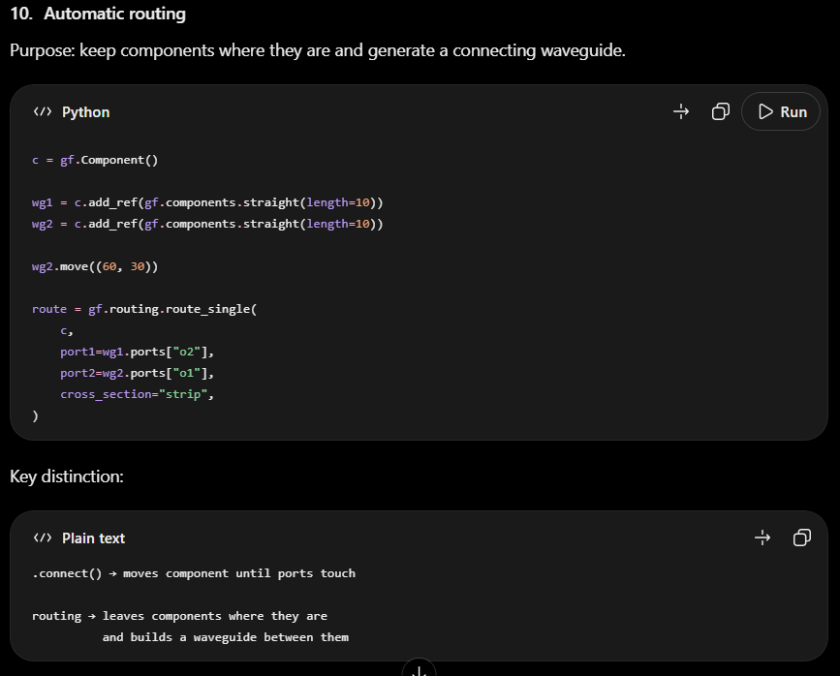

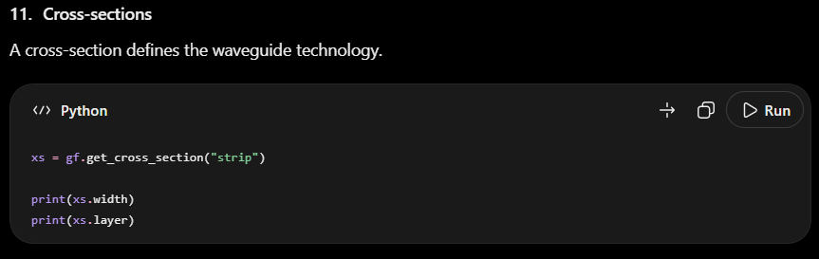

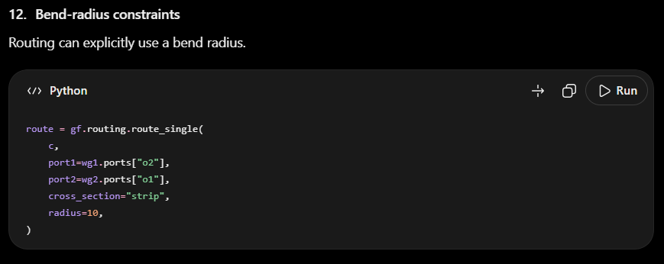

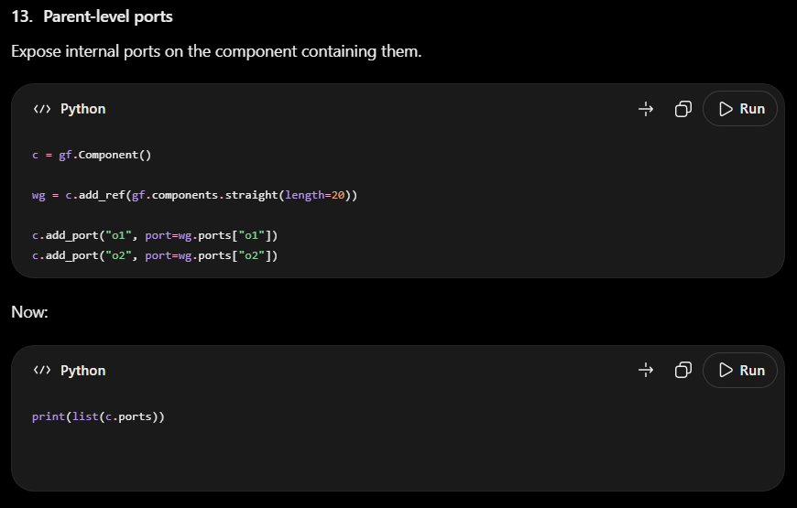

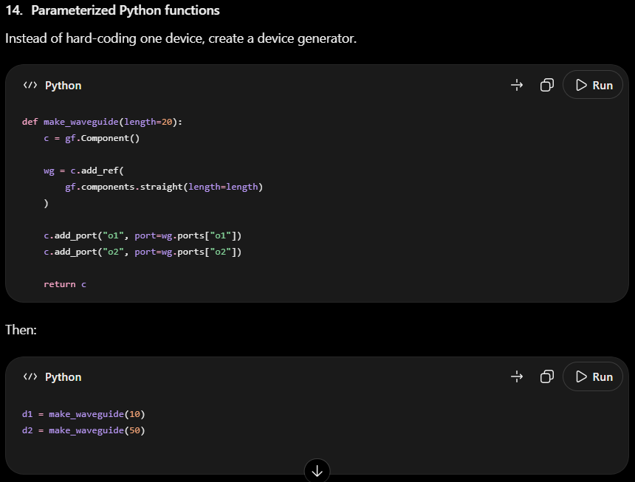

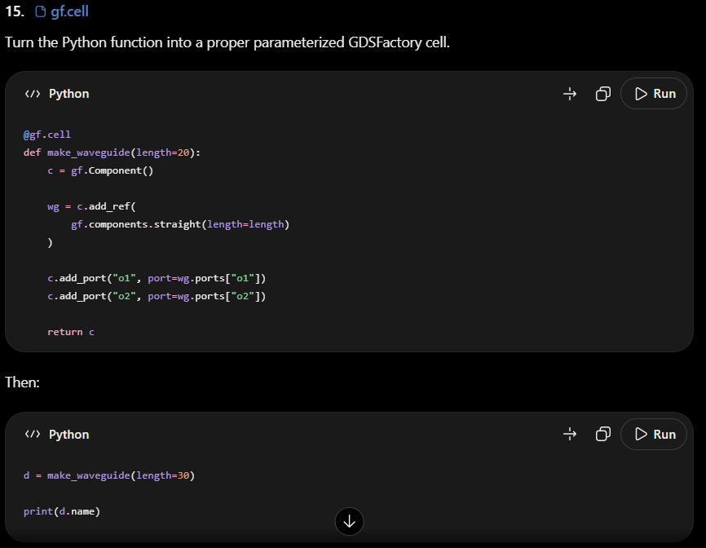

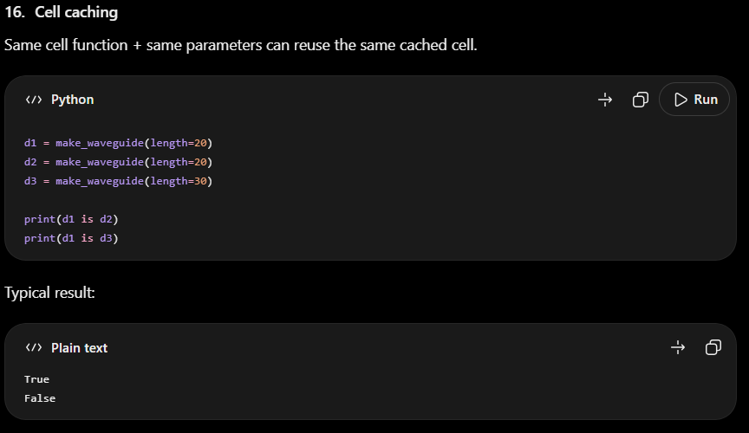
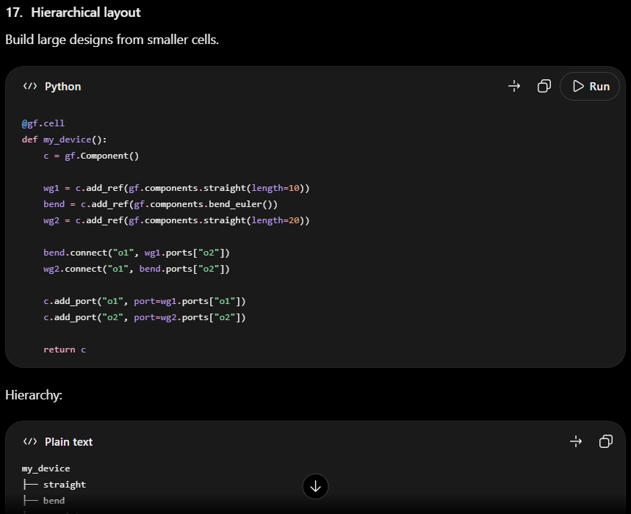

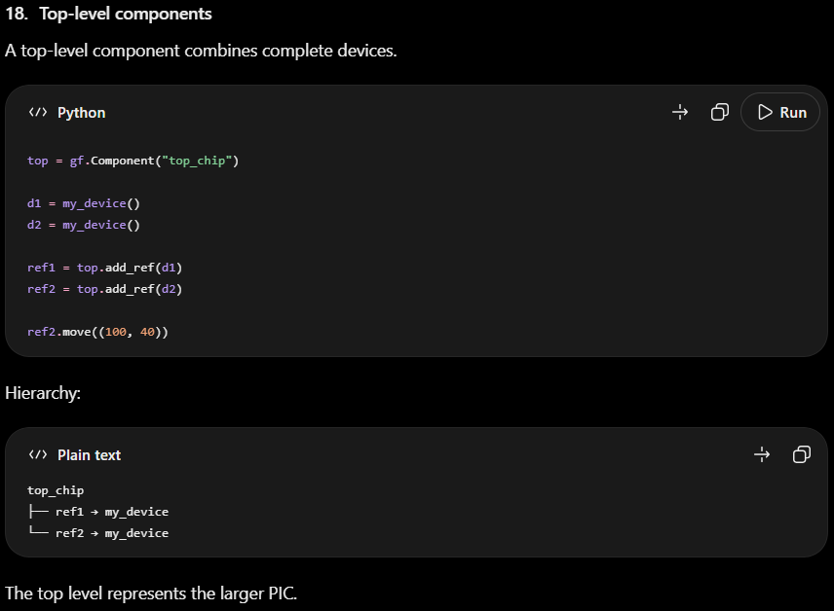

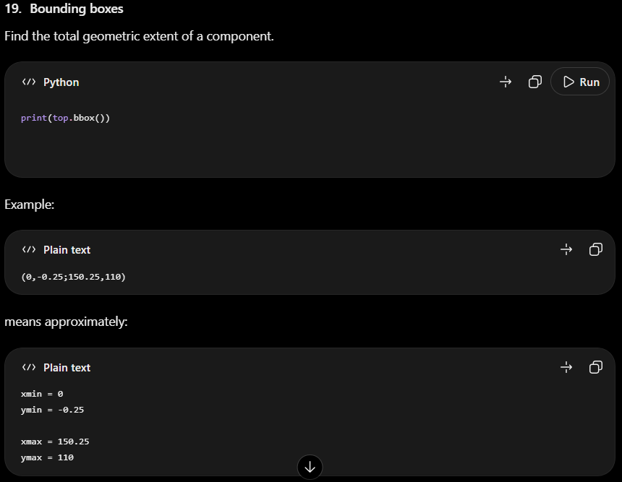

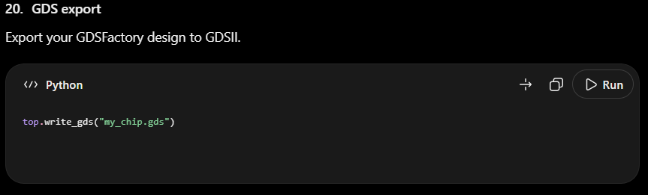

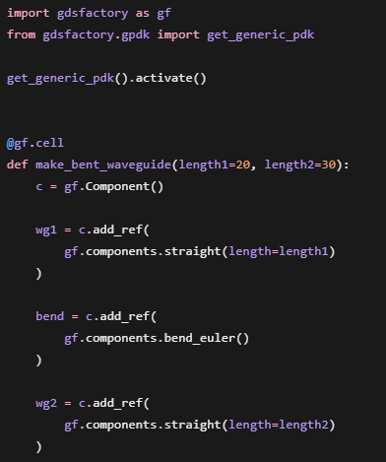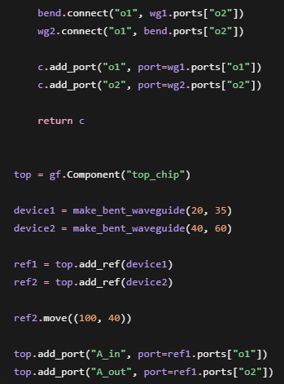
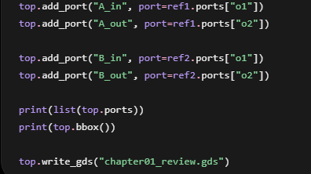
import gdsfactory as gf
from gdsfactory.gpdk import get_generic_pdk

get_generic_pdk().activate()

@gf.cell
def make_bent_waveguide(length1=20, length2=30):
c = gf.Component()

wg1 = c.add_ref(
gf.components.straight(length=length1)
)

bend = c.add_ref(
gf.components.bend_euler()
)

wg2 = c.add_ref(
gf.components.straight(length=length2)
)

bend.connect("o1", wg1.ports["o2"])
wg2.connect("o1", bend.ports["o2"])

c.add_port("o1", port=wg1.ports["o1"])
c.add_port("o2", port=wg2.ports["o2"])

return c

top = gf.Component("top_chip")

device1 = make_bent_waveguide(20, 35)
device2 = make_bent_waveguide(40, 60)

ref1 = top.add_ref(device1)
ref2 = top.add_ref(device2)

ref2.move((100, 40))

top.add_port("A_in", port=ref1.ports["o1"])
top.add_port("A_out", port=ref1.ports["o2"])

top.add_port("B_in", port=ref2.ports["o1"])
top.add_port("B_out", port=ref2.ports["o2"])

print(list(top.ports))
print(top.bbox())

top.write_gds("chapter01_review.gds")

